Contents

OOP Theory 1

CPS Theory 1

Introduction to Software Engineering 2

Islamiyat 2

# OOP Theory

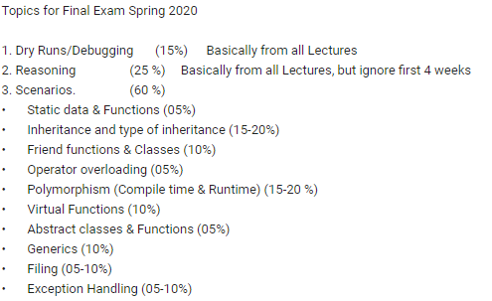

# CPS Theory

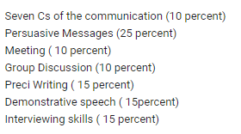

# Introduction to Software Engineering

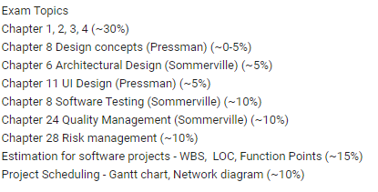

# Islamiyat

